Kindly see the color highlighted points,
Green is updated, Yellow in progress, Blue required understanding,
- HS code complete backup needs to update for adding items in invoice section. (Due to Data cleaning in the file that required time, because in that there are multiple special character found)
- GD collectorate prefix. (Updated)
- GD serial number shouldn’t be strict to 4 digits only. (Updated)
- SASPAK or AL MADINA should be mentioned in Job form. (Drop down)
- Types of Packages. (Not yet updated) (will be updated today)
- Office / Warehouse Address. (Add multiple addresses for each party/customer) Party Location Form is available in Parties Setup
- All GD`s Types needs to update (Consignment Category & Declaration Type). (Required some understanding)
- Import GD file alignment out. (Provide me the GD File which you are uploading)
- Process Owner List in party setup (Updated)
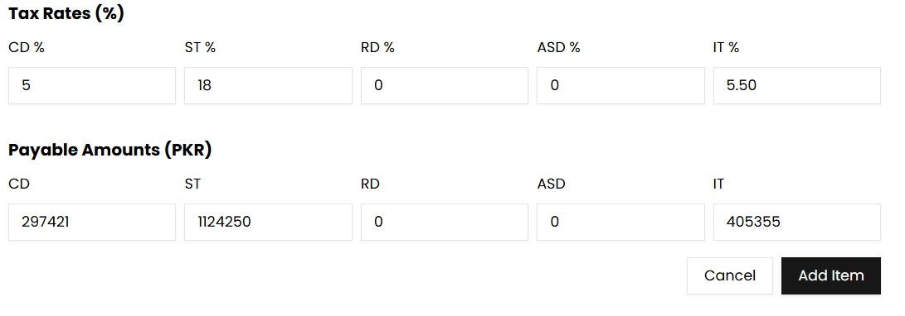
- TAX RATES: ASD should be AST (Updated)

- While update items in GD Section: this error found. (Kindly provide me the GD file)
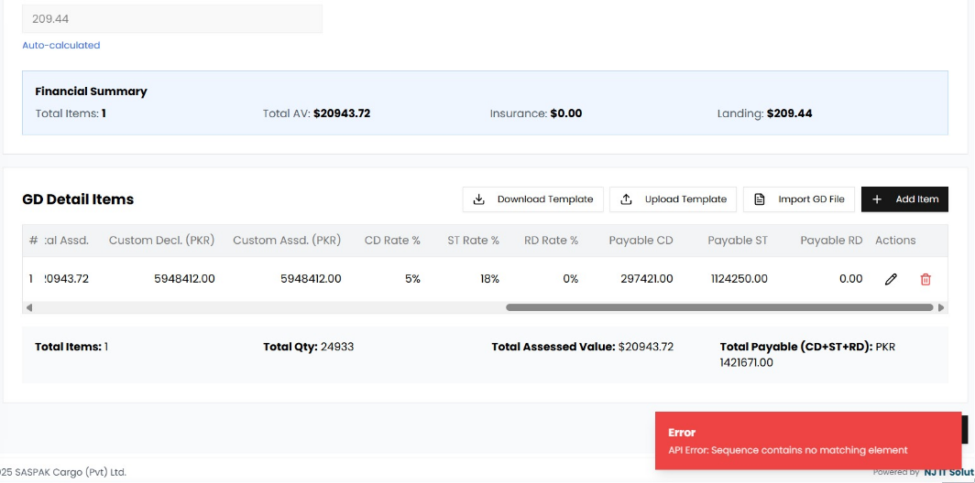
- While updating Detention Section: facing same issue (Updated)
